
The Rural Kent Coffee and Information Project Annual Review
March 2018
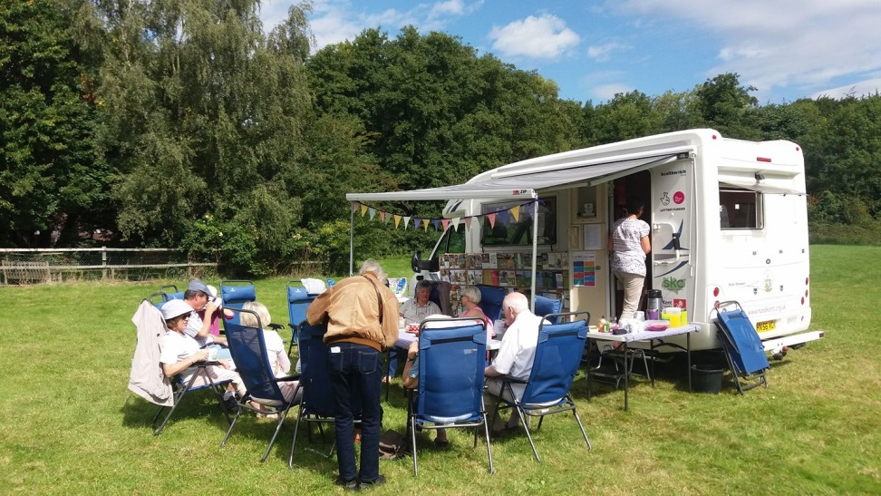

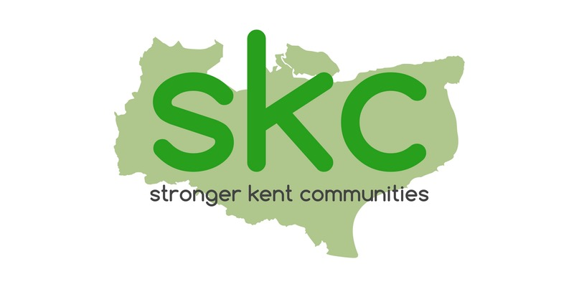
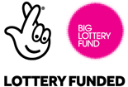



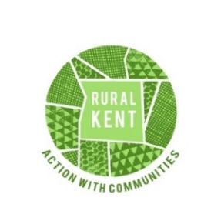


Acknowledgements

The Rural Kent Coffee and Information project is a Rural Kent Project funded by KCC through Stronger Kent Communities, Engaging Kent CIC through Healthwatch Kent CIC, the National Lottery through the Big Lottery Fund, Intuiti Solutions Ltd, Kent Police and Crime Commissioner Communities Together Fund and Norris and Fisher.

We are grateful for the In-Kind donations made by GoPak and the Farthing Common Plant Centre.

The project has been inspired and continues to be generously supported by Sally Fogden, Ann Osborn and Garry Simmonds of the Suffolk Coffee Caravan and we are grateful for their ready willingness to share their knowledge, experience and friendship with us.

The project would not have been possible without the overwhelming support of our volunteers, Jane and Rodney Watts, Pamela Smith and Mick Burgess and to Rural Kent staff, Liza Davies and Tessa O’Sullivan. Their warm welcome, friendly smiles and attentiveness at the right times have enabled us to gain an insight in to the loneliness and isolation of some of our residents.

Underpinning the success of the project are the community volunteers: Parish Councils, community activists and other residents who have actively helped us to find the right spot to set up our café and spread the word about our visits.

Our Steering Group has been an invaluable source of support and encouragement. Thank you to Lesley Riding, Kay Coulton and Lead Volunteers, Jane and Rodney Watts.

We would also like to thank our partners, for their encouragement, enthusiasm and promotion of the project, to help reach those who need it most.

Thanks to Hester and her team of the Ark Bakery Shared Lives Project and our volunteer cake bakers for providing delicious homemade cake throughout the year.

The Kent and Suffolk Teams at our launch in April 2017
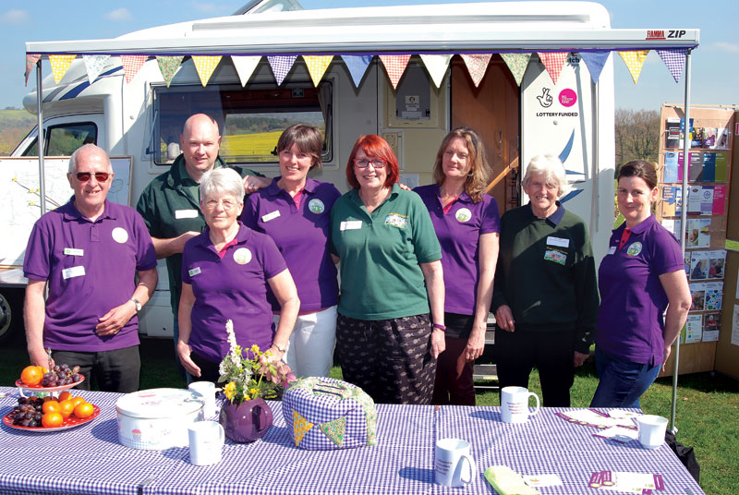
1 Introduction

The Rural Kent Coffee and Information Project (the Coffee Caravan) helps to tackle isolation and loneliness by providing a mobile pop-up cafe and information hub, free to communities and open to all.

The project provides a mobile venue for free tea, coffee and cake and supplies friendship and information. Using a campervan, with an awning, tables and chairs, we park in a village for a couple of hours, to enable residents to get together with others in their community who they might not otherwise meet. Staff and volunteers 'on board' are on hand to provide company, or to sign-post residents to services that they might need. The aim is to reach people who are not already engaged either in their own community or with outreach organisations, by befriending them, building their confidence and putting them in touch with services that they might need or benefit from.

Inspired by the successful and well-established Suffolk Rural Coffee Caravan project, it wasn’t hard to imagine that if loneliness and isolation were a problem there, then surely they were in Kent too. Thankfully our funders, The National Lottery, (through the Big Lottery), Healthwatch Kent and Kent County Council (through the Stronger Kent Communities Consortium), agreed with us and in April this year, we launched our own project.

One year later and allowing for the planning and start-up phase of the project, we have already carried out an impressive 71 visits to 18 Kent communities. We have served over 1000 people and had requests from communities involved to continue our visits into the winter months. We have been joined by representatives from 26 different agencies and have signposted individuals and organisations to a wide range of support services. Over 750 leaflets, surveys and other promotional materials have been handed out.

1.1 Administrative Information
Organisation: Action with Communities in Rural Kent Charity Number: 212796
Registered Office: The Old Granary, Penstock Hall Farm, Canterbury Road, Brabourne TN25 5LL
Project Name: Rural Kent Coffee and Information Project
Project start date: 1st January 2017

Staff
Kathy Bugden

Rural Kent Staff In-Kind
Tessa O’Sullivan
Liza Davis

Volunteers
Jane Watts
Rodney Watts
Pamela Smith
Mick Burgess
Lee Davis
Kay Coulton

Steering Group
Kathy Bugden
Jane Watts
Rodney Watts
Kay Coulton (Organisational Development Adviser)
Lesley Riding (Healthwatch Kent)

1.2 Our Aim

To help tackle loneliness and isolation in Rural Kent by bringing people together in their own community to provide information and possibilities.
2 Annual Review
2.1 April to October 2017 at a glance¹

Number of visits | 71
Number of visitors | 996
Number of returners | 198
Number of males | 305
Number of females | 691
Number of pre-school children | 65
Number of school children | 39
Number of working age | 225
Number of over 60 year olds | 665
Number of volunteers | 27
Accompanying agencies | 26
Number of community organisations/groups and local enterprises in attendance | 46
Number of community organisations/groups and local enterprises supported | 27
Number of community organisations/groups and local enterprises advised/signposted | 14
Number of leaflets/other promotional materials distributed² | 767
Healthwatch materials taken | 173
Healthwatch surveys completed³ | 1
¹ Does not include winter visits
² Includes Healthwatch materials
³ Does not include surveys completed by HW staff/volunteers

2.2 Places we visited

District/Unitary | Community
Ashford | Charing Heath, High Halden
Canterbury | Adisham, Tyler Hill
Dover | West Hougham
Dartford | Joyners Wood
Gravesham | Harvel
Maidstone | Collier Street, Laddingford, Langley, Ulcombe
Medway | Hoo Marina Park (Hoo)
Sevenoaks | Farningham, Four Elms
Shepway | Newchurch
Tonbridge and Malling | Mereworth, Wouldham
Tunbridge Wells | The Moor (Hawkhurst)

2.3 People we worked with

Ashford Borough Council Environmental Health
Ashford Volunteer Centre, Care Navigator
Carers First
Circle Housing
Family Mosaic
Headway
Healthwatch Kent
Healthwatch Medway
KCC Community Wardens
KCC Libraries (Dover)
Kent and Medway Youth Trust
Kent Association for the Blind
Kent Police (Wouldham, Tyler Hill, Adisham)
Kent Police and Crime Commissioner
Medway Hospital
Medway Mobility Bus (ASD Coaches)
Mobile Library Service (Shepway, T’ Wells)
Mobile Post Office
North West Kent Volunteer Centre
Porchlight (Ashford)
Red Zebra
Rural Kent Trustee
Sevenoaks District Council Housing Team
West Kent Communities
West Kent Housing
WHoo Cares

2.4 Our first-year learning, insight and progress report

At the beginning of the project we wanted to be sure we had a user friendly and useful method for monitoring what worked and what didn’t and for evaluating our progress. This would give us insights into our impact on communities we visit. Early on we held a Theory of Change Workshop with a freelance evaluation and participation advisor and drew up aims and outcomes for the project (see below). We then drew from these a series of tracking progress indicators that we used regularly to help plan and redirect the project where necessary. There was a daily log and prompt sheet kept in the Caravan and at the end of every visit staff and volunteers would use these for reflection on what went well, any hiccups and any interesting anecdotes to share.

Roughly every three months we held a Review Meeting with the Coffee Caravan Project Manager, key volunteers Jane and Rodney, and Rural Kent staff as part of in kind support. We asked ourselves a series of reflective questions and included space for planning future activity. The Steering Committee, comprised of the Coffee Caravan Project Manager, a freelance grants consultant from Funding for All, the Information & Engagement Manager from Healthwatch Kent, and our two lead volunteers, met after the Review Meetings.

Coffee Caravan Aim and Desired Outcomes
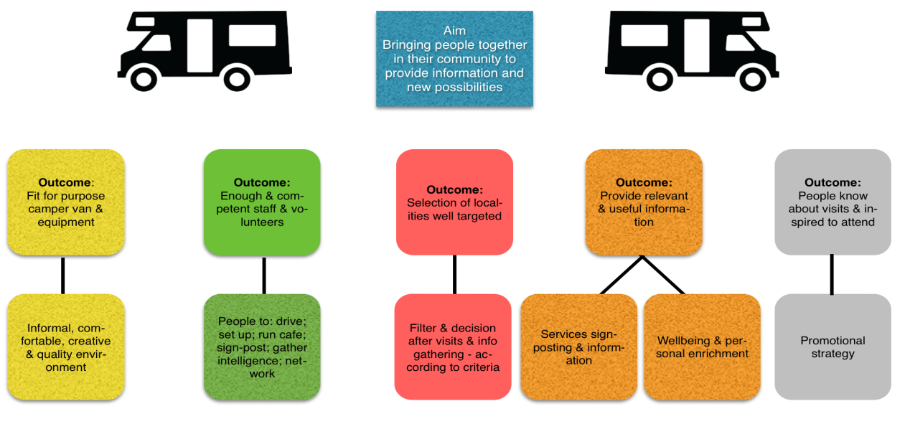

At all stages of the project staff and volunteers were encouraged to reflect and collect useful information and anecdotes. They also completed a Staff/Volunteer Survey and Feedback Form. The Coffee Caravan Project Manager met several times with the evaluation and participation advisor, to help collate information and produce Our first year learning, insight and progress report (March 2018), available on request. The report concentrates on more qualitative learning and insights but a considerable amount of hard data has also been collected, again available on request.

In addition, Engaging Kent CIC has recently done an interim study of the Social Return on Investment (SROI) of the Coffee Caravan project. Although a work in progress, initial findings show that for a £30,000 investment in the project the Coffee Caravan to date has produced over £228,000 in social value - £7.56 for every £1 spent. This figure is based on the contribution of Healthwatch volunteers and does not yet include those working directly with the project.

2.5 Unexpected outcomes

Doing good does you good?
Early in the planning of this project, a number of people commented that they thought people would take advantage and come in droves for the free tea, coffee and cake. We included a discrete donations tin on our table. Some people haven’t donated and some have donated the few pennies that they’ve had on them but in many cases, the generosity has surprised us. There is a feeling that people appreciated having something done for them and the kindness on offer and that this is generating a reciprocal act through the donations.

Winter Visits
As the summer visits came to an end, we were asked by several of the communities (High Halden, Hawkhurst, West Hougham, Laddingford, Four Elms, Adisham, Farningham and Wouldham) if we could continue through the winter months. Volunteers, Rodney and Jane Watts were happy to continue through November, February and March. Intuiti Solutions Ltd kindly offered funding for some winter visits and in two cases, Parish Councils offered to fund them. In addition, Harvel ran their own successful event in December. Two visits had to be cancelled due to icy road conditions.

Winter Visits at a Glance

Number of visits | 19  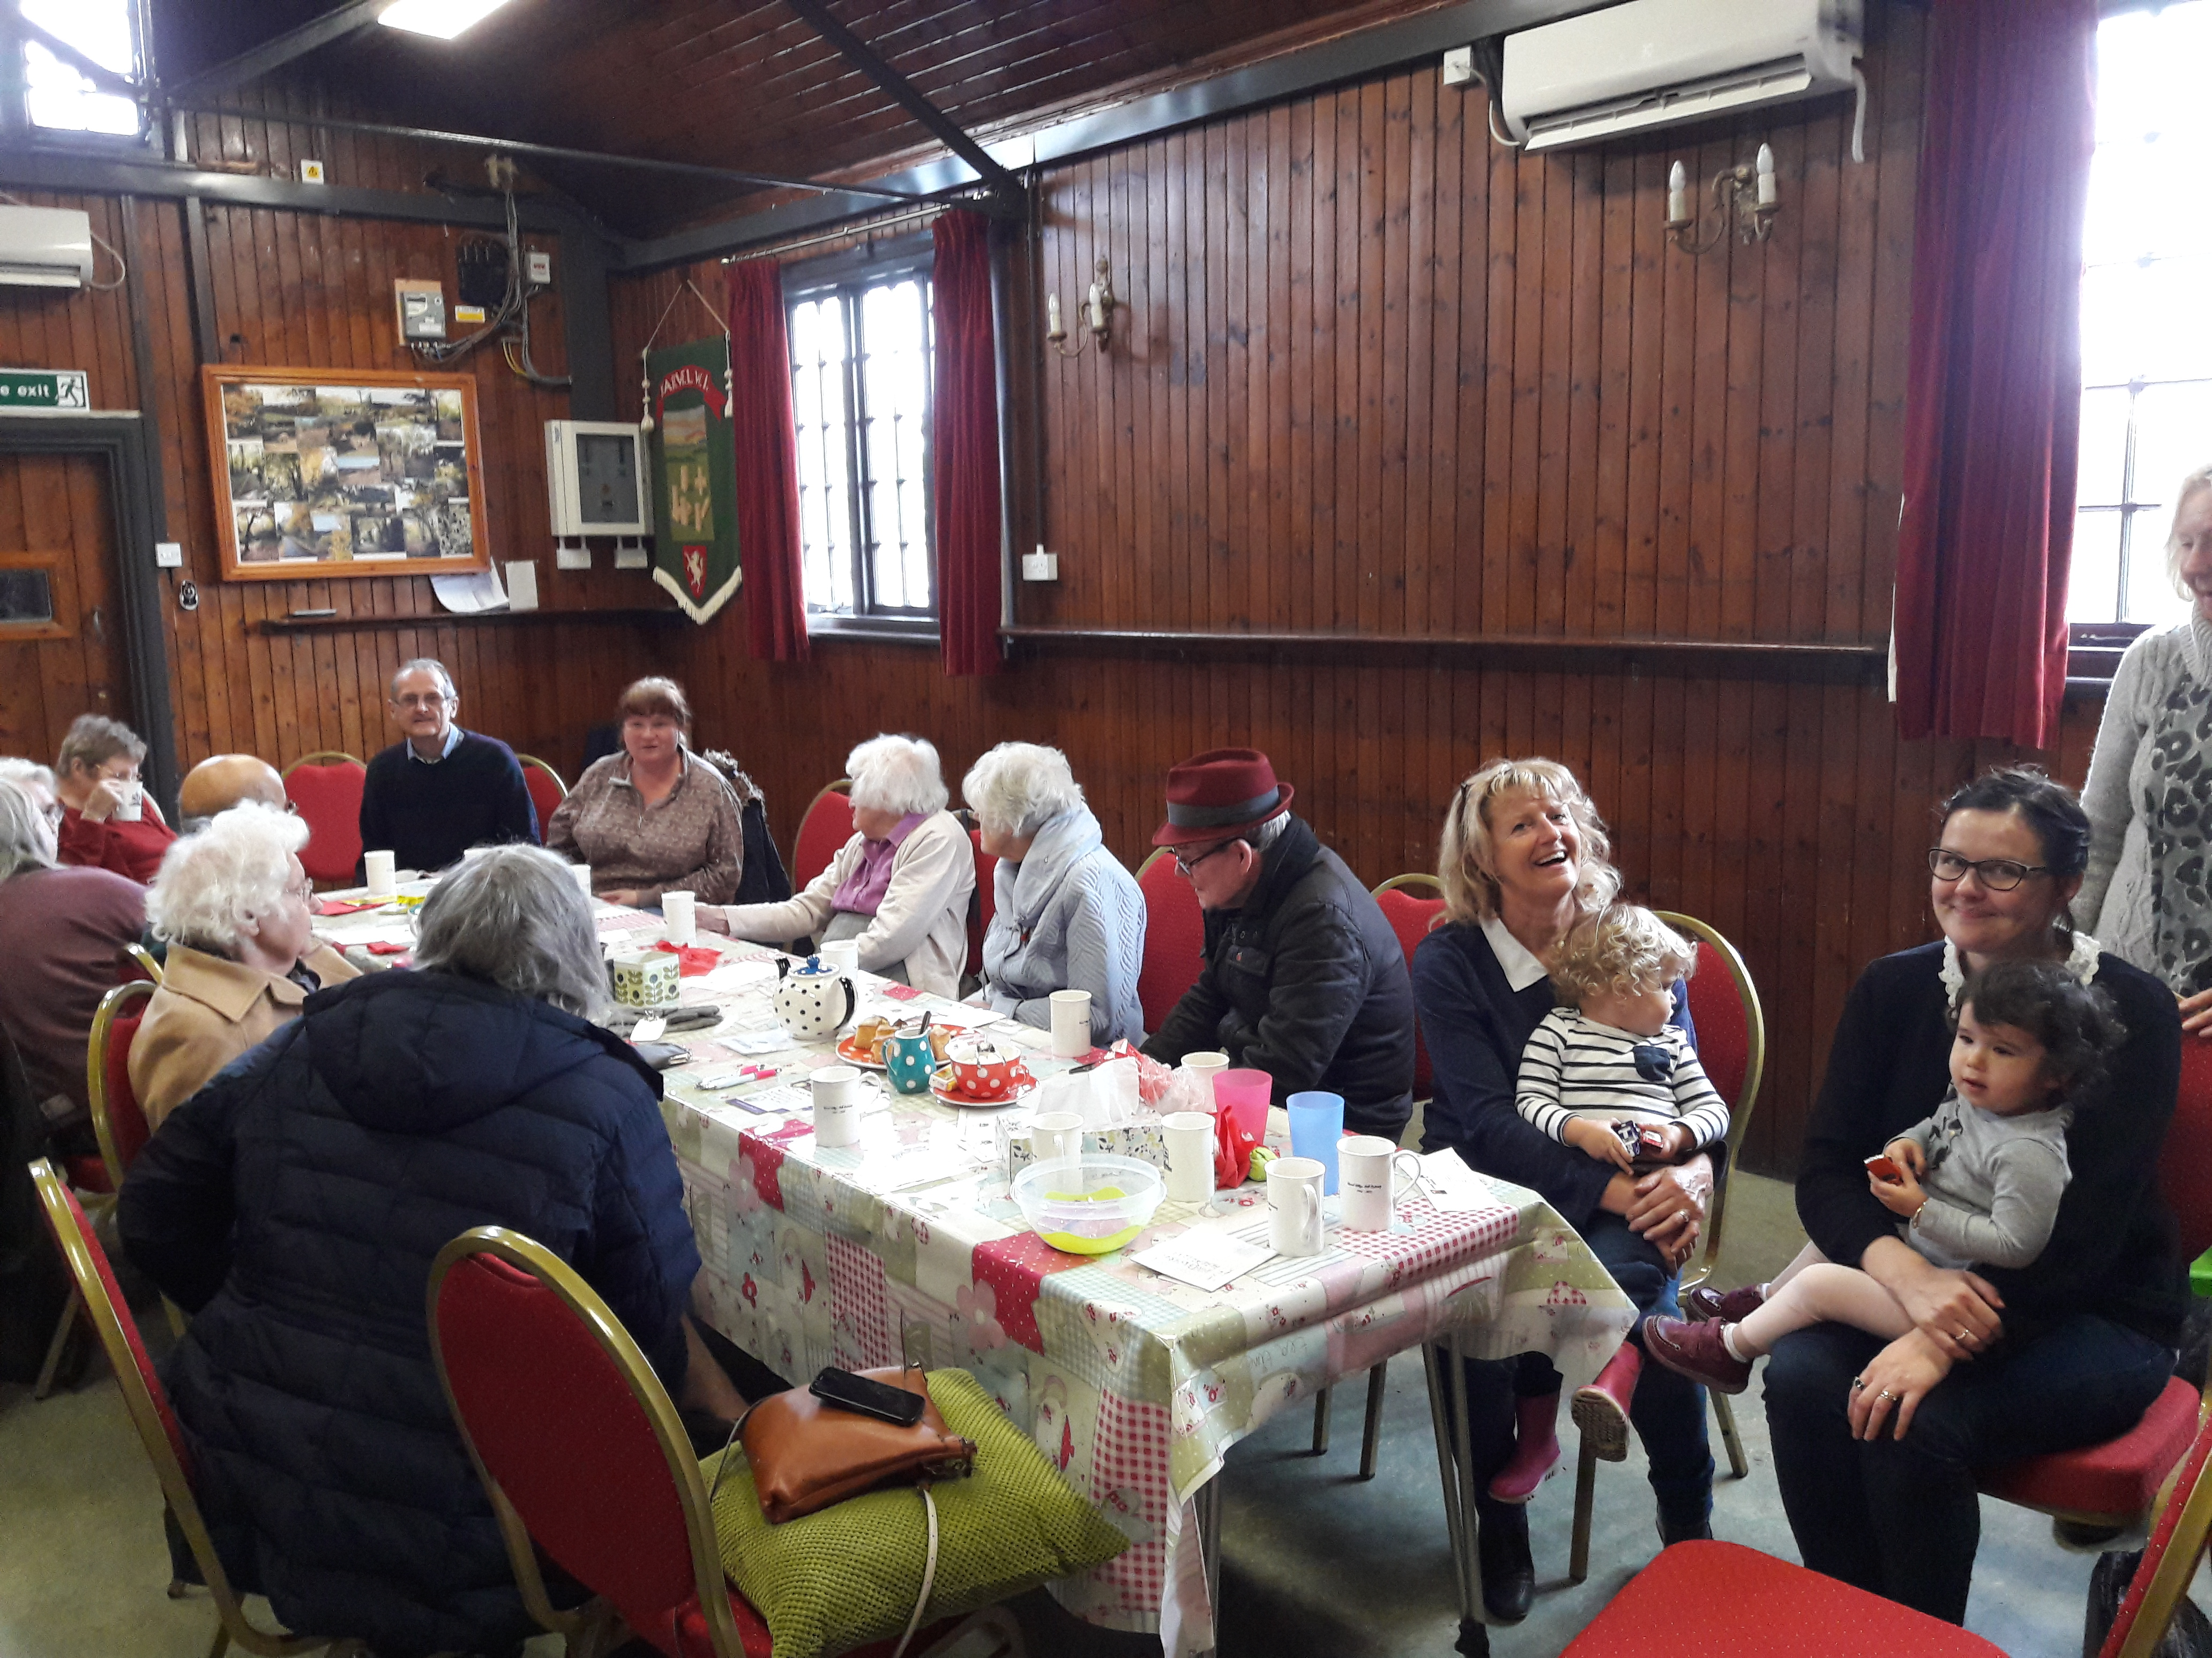
Number of visitors | 210
Number of returners | 141
Number of males | 58
Number of females | 152
Number of pre-school children | 12
Number of school children | 1
Number of working age | 39
Number of over 60 year olds | 158
Accompanying agencies | 5
Healthwatch materials taken | 58
Winter warmth in Harvel

Tackling Loneliness and Isolation
At the time of writing this report the Government has just appointed the first Minister for
loneliness, Tracey Crouch and it intends to publish a strategy on tacking loneliness in the UK by the end of 2018. In an article by her in the Times (18th January 2018) she states that 85% of young disabled adults, eight out of 10 carers, and a quarter of parents, feel lonely and/or isolated. Around 200,000 older people have not had a conversation with a friend or relative in more than a month.

It is difficult to quantitively evaluate the impact of the Coffee Caravan Project in tackling loneliness and isolation in the Kent villages we visited but the following insights are useful:

“Two women didn’t know anyone by name. One said she was fairly new to the village and wanted to start doing something... as she knew if she didn’t, she would quickly become lonely and feel isolated. These two ladies left the session exchanging addresses and arranging to ‘drop in’ on each other.”

“One lady had lived in [the village] for 57 years and had recently lost her husband. She was struggling with some health problems herself and clearly grieving. She said that she had really enjoyed the visit and how good it was for her trying to get back in to things.”

“One lady announced on her arrival that she was new to the village and chatted away to everyone there. It turned out she had actually lived in [the village] for 3 to 4 years but she still felt new and didn’t know anyone. The same lady came on the last visit and commented that she wouldn’t go out in the winter as there was nothing to do.”

“There were some who didn’t know each other. This included a mum of a baby and toddler who had lived there for 5 years but hadn’t met any of her neighbours. She told us that she had made a friend with similar aged children in [the neighbouring village] by noticing that she had the same postcode as her when she signed in at the Children’s Centre.”

“One 86 year old woman in a mobility scooter arrived early and waited for us to open. She talked about her increasing dependency on neighbours for support. She enjoyed having the opportunity to meet up and chat with locals on her doorstep.”

“One older couple have attended each of our visits in their community. He has dementia and she is his carer. Initially the couple sat together. They didn’t know others around the table but introduced themselves and joined in with the chatter. One of our volunteers had a good conversation with the wife about the impact of her husband’s dementia on her. She was finding it hard. The volunteer gave her a Carers Support leaflet. At our next visit it was great to hear that she was meeting up with the local support group to go to the cinema that evening. The lady said “I want to chat. My husband doesn’t chat at home and I miss the conversation”. The husband, however, has become increasingly chatty as the visits went by, leaving on one occasion, shaking our hands and saying “thank you, this is a wonderful place”. Asked if we would continue coming through the winter months, the Parish Council agreed to fund some indoor visits, alongside the mobile Post Office in the hall. On the most recent visit the wife commented to one of our volunteers that she was “so glad to be here. She was having a difficult day”. There is now a familiar group of residents attending with some others coming and going. The chatter is always lively and the volunteers that attend there feel they are amongst friends.”

“One couple said they had lived in their village for 18 months. They regretted moving. They went for walks but never saw anyone out and about on the streets as there was nowhere to walk to. Now that the bus service had been cut it was even worse. They used to see people at the bus stop but they couldn’t do that anymore.”

“The project is amazing. A great way to bring people together. It would be great if it happens more often. I’m shy but felt welcome. It definitely brightened my afternoon, which I thought would be gloomy”.
Joydens Wood on a very wet and windy day!

A word about sustainability
We were delighted to be the subject of the Yours Sustainably blog on local initiatives:
https://www.yourssustainably.com/blog/the-coffee-caravan-project-visits-laddingford/

2.6 The Year Ahead
The 2018 schedule will begin on the 16th April. The first quarter of the year has been spent identifying communities, with particular effort made to reach communities in Swale and Thanet. Special thanks to the KCC Community Wardens who have helped with this.

A number of action points were flagged up from our learning in 2017. These have been reviewed and the following steps taken:

- The majority of visits in 2018 will be supported by someone from the local community, aid local ownership and action, to provide local information and development the volunteer pool with an additional pair of hands!
- We will have the additional support of a paid driver for one day a week to enable adequate cover for illness, holidays and help to share the current workload, making the service more robust.
- The staff/volunteer balance has been reviewed and adjusted reflecting the additional driving support.
- Effort has been made to engage communities in Swale and Thanet. This has not proved easy for a number of reasons but we are pleased to make a start in Eastchurch (Isle of Sheppey, Swale) and Manston (Thanet).
- The information hub has been reviewed and streamlined. Thanks go to Healthwatch Kent for their advice on this. A handout resource is being produced that will be available for residents and for the organisers of those communities who decide to ‘do it for themselves’.

Until now the project has relied heavily on a short film made by the Suffolk Coffee Caravan project for promotion in Kent. We are grateful to Intuiti Solutions Ltd, who have donated some additional funding to help us make a short film of our own.

Kathy Bugden
Project Manager
Rural Kent Coffee and Information Project
Action with Communities in Rural Kent
The Old Granary
Penstock Hall Farm
Canterbury Road
Brabourne
Kent TN25 5LL

Tel: 01303 813790
Email: coffeeproject@ruralkent.org.uk
www.ruralkent.org.uk/coffeeproject

Registered Charity No: 212796

