As Mike is away in Queenstown this week attending the NZEI Rural Principal Conference, we have decided to share some pictures from the Pamper Night, held last night.

Those who attended enjoyed the facials, nail painting, massaging, eyelash tinting etc and being served with nibbles and wine. The clothes swap was a huge success. This was such a fun night out and everyone enjoyed themselves – watch this space for the next ladies evening!!

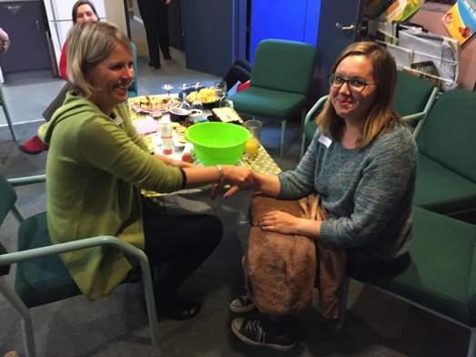

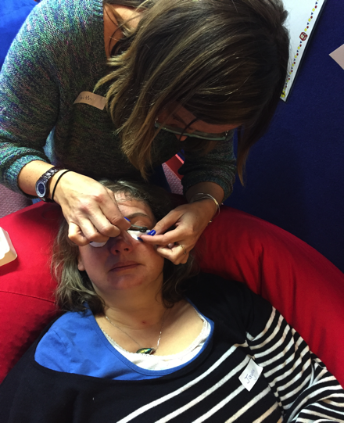

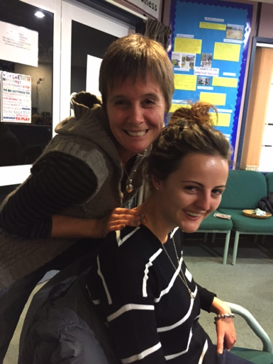

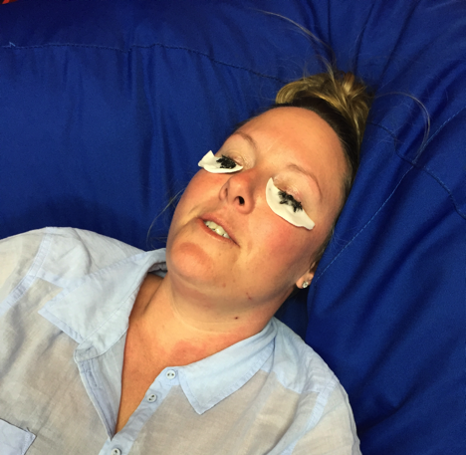

School News

Virtue this Term is
Consideration

Te Rerenga o te Wiki

Here are some phrases to tell your children how wonderful they are.

You're very good.
Ka nui tō pai.

Awesome.
Tūmeke

You've done a good job.
He tino pai raw tō mahi.


That's beautiful.
Pai rawa atu tēnā.

Office Cell Phone 0277572058
Remember this is a great way to let us know if your child is absent or if you have a change of pick up plans.

Invoices
School invoices have been sent home last week. There are still a few camp fees to be paid, could these please be paid ASAP. Please remember to pay bus fares and class camps/trips before the end of the term. If you would like to set up an Automatic payment, please come and discuss this with Pauline. Thank you.

Pool Keys
Just a reminder that all pool keys need to be returned to the office in the next couple of weeks. Thanks



Reminder
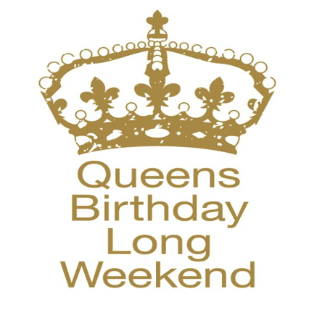


Beanie Week!!
Next week we
would like to fundraise
money to help the Burchell
family and support Brain Cancer Awareness. We kindly ask if children can wear a beanie and bring in $2.00


Netball

No Netball this weekend

Important Dates!

01.06.15 Queen’s Birthday
03.06.15 Tapuwae Tournament
03.06.15 ICAS Science Exam
09.06.15 Totara MOTAT Trip
09.06.15 Rimu – Sugar Movie
10.06.15 Te Puru School Open Day
16.06.15 ICAS Spelling Exam
26.06.15 Mid Year Reports

Term 2 Assemblies

29.05.15 Matai
05.06.15 Kowhai
12.06.15 Pohutukawa

Term 2 Finishes

Friday 3rd July 2015


Community News

Flat For Rent
Flat available to rent in Te Puru. Suit Professional working adult. Fully furnished, great location.
Phone 8682180

For Sale
Front Loader washing machine,
good working order, excellent
condition - $150.00. Phone Bev
8682180

DANCE EVENT


Ngatea War Memorial Hall, Sunday 31st May, 2 - 3.30pm (incl pm tea). As a thank you to our sponsors and community supporters, Kimberley Mear and Aidan Tully will present the dances and talk about their experiences at the recent Alana Haines Australasian Competition in Wellington. This competition attracted 400 entrants and was judged by an international panel of top level judges. Aidan won a scholarship to study in Alabama, USA and former student Vida Polakov was the winner of the senior section.
Additional items by THBT
students. Gold Coin
entry. For more information
phone 027 2428896

FREE EAR CLINIC SERVICE FOR CHILDREN Term2 (2015)
All children must be accompanied by Parent or Caregiver

Thames | Thurs 11 June | 9.30 am - 12pm

Te Puru Creative
Kidz Art Club
Spaces available Tues – Fri 3.00pm – 5.00pm, phone Linda 8682991 (by tennis courts at Te Puru Hall)

Accommodation Wanted Te Puru School Family wanting a 2/3 bedroom house to rent.
Phone Michelle 8682505

Wanted
Second Hand girls year 9 THS uniform. Please phone
Lisa 0276904152

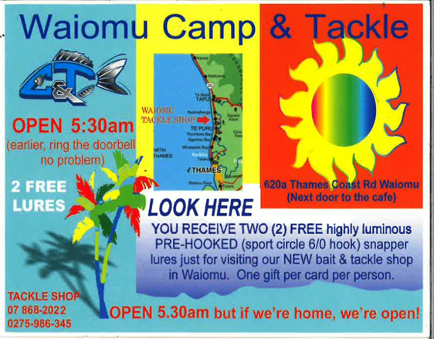


Have a great long weekend everyone!!

