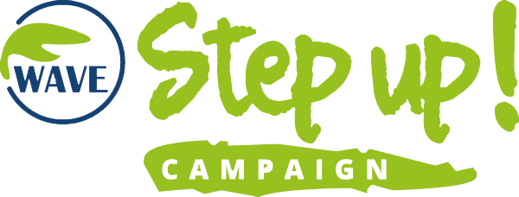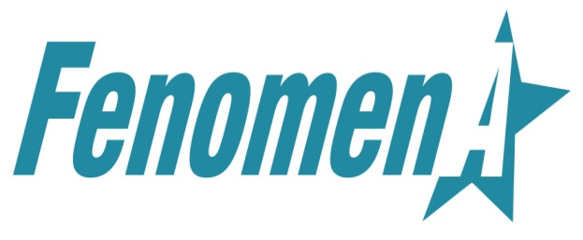

WAVE CALL FOR YOUTH AMBASSADORS

Are you the one who cares?
Are you passionate about creating positive change and actively shape policies on a higher level?
We want you to become our youth ambassador!

The WAVE Network* is looking for young and committed visionaries to join a peer group of youth ambassadors for our Step Up! Campaign. The Step Up! Campaign is a Europe-wide project of the WAVE Network, aiming at increasing efforts to stop violence against women, raising awareness of the issue, and protecting survivors of violence against women and girls.

The group will consist of up to 10 young people from the participating campaigning countries.**

You are:
- 18 – 27 years old and have a good command of the English language;
- aware of the issue of violence against women and girls and its prevalence;
- willing to actively engage, as a volunteer, with a group of your peers from all over Europe for the next 2 years,
- willing to develop new skills and gain experience in the field of women’s rights,
- willing to create engaging content and help us spread important messages among young people.

We are offering you a unique and pioneering experience. In your role, you will have a chance to make a difference in Europe, and to become a true human rights activist.

The call is open from 25 May to 21 September 2018.

How to apply? Click on the link to go to the application form: https://bit.ly/2LsUkvs.

The youth ambassadors will be announced on Wednesday, 3 October 2018.

* WAVE Network is the only European network of women's organisations, focusing solely on the elimination of violence against women and children. Established in 1994, it now consists of more than 130 NGOs from 46 countries.
** The countries participating in the campaign in 2018 are: Albania, Bulgaria, Croatia, Cyprus, Estonia, Finland, Georgia, Italy, Kosovo, Macedonia, Moldova, Montenegro, Poland, Portugal, Serbia, Slovakia, Spain, and Ukraine.

WAVE Youth Ambassador Tasks and Responsibilities:

- Contribute to the strategic development and practical implementation of the Step Up! Campaign
- Actively participate in online group meetings (every 2 months)
- Attend online trainings and workshops
- Propose ideas, solutions and activities regarding youth inclusion in promoting non-violence
- Suggest and prepare social media posts (Facebook, Instagram etc.) for publication according to a social media strategy, with information on relevant events
- Regularly check-in with coordinators to make sure both the Youth Ambassador and coordinators are aware of what you are working on, and that both parties are content with the work
- Length of engagement is minimum 12 months, maximum 24 months
- Expected engagement is around 1-2 hours per week. Occasionally the engagement may increase, but that is to be agreed in advance with every Youth Ambassador
- The role of Youth Ambassador is unpaid, but offers ample opportunities for skills development, building knowledge and developing an activist mindset.

Whilst every endeavour has been made to outline the duties and responsibilities of this post, these duties are not exhaustive.

Vienna, 24 May 2018

