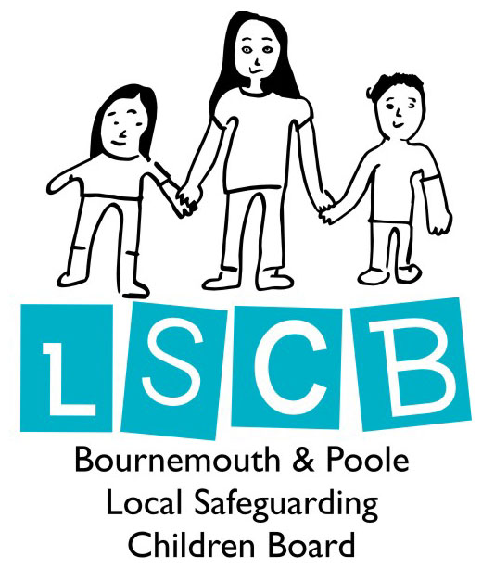

**Keeping Children Safe in Education**

Information for Parents/Carers

Further safeguarding information can be found on the school website and the LSCB parent section <http://www.bournemouth-poole-lscb.org.uk/parents/>

**If you have any safeguarding concerns about either your child or another child talk to the Designated Safeguarding Lead at the school, their deputy or another senior member of staff. Alternatively you can contact:**

Bournemouth MASH 01202 458101 or [MASH@bournemouth.gov.uk](mailto:MASH@bournemouth.gov.uk)

Poole MASH: 01202 735046 or [childreferrals@poole.gov.uk](mailto:childreferrals@poole.gov.uk)

Police on 999 in an emergency

or 101 for non emergency

NSPCC 0808 800 5000

Childline 0800 1111

Bournemouth and Poole LSCB Safeguarding in Education Sub Group February 2017

**Safeguarding Issues**

**Attendance** – your child’s attendance is monitored daily and significant absences are always followed up by the attendance officer. The school has an attendance policy that you should read and understand.

**Behaviour** – the schoolhas clear behaviour rules for the whole school community that must be followed to keep everyone safe and happy. We understand that children do sometimes fall out and this will be dealt with by an adult who will listen to the children involved and help resolve the situation.

**Bullying** – the school takes all cases of bullying very seriously and will work with children and families to try and resolve any problems. The School has an anti-bullying policy that you should read and understand.

**Health and Safety** – Everyone at the schoolhas a responsibility to ensure that adults and children work in a safe environment. The school has a clear health and safety policy which everyone must follow. The school have fully trained first aiders to deal with any accidents in school.

**E-Safety** – The school recognises that technology plays an important role in the education of or children and is committed to safeguarding children in the virtual world. To support parents, the school has e-safety information to help keep your children safe both in school and at home.

**Complaints** – If you have any complaints about how the school is working with you or your child please feel confident to speak to us. The Head Teacher will always be happy to speak to you to resolve any difficulties. It is better to speak to us as soon as you have a concern so that it does not become a bigger issue. If you do not feel the matter has been resolved, you can raise your concerns with the governing body.

**What a School Must Do**

A child should be able to go to school and feel safe so that they can achieve their very best.

* Anybody who works or volunteers at this school will be vetted to make sure they are safe to work with children and then trained to identify child abuse and what to do if they are concerned.
* The school has a Designated Safeguarding Lead (DSL) for Safeguarding, who has had extra training to know what to do when a concern is brought to them.

The DSL is: Mrs A Carter

The Anti-Bullying Champion is: Mrs V Jackson

The E-Safety Champion is: Miss D Brunel

The Pastoral Care Worker is: Mrs D Worboys

* We will always listen to you and work closely with you if we are concerned about your child. Sometimes, concerns cannot be shared with you before Social Care have become involved. The school has a safeguarding policy which tells you more about this and when we must speak to the police or children’s services. Please ask us about how you can see a copy of this policy.
* We will help your child to learn about keeping themselves safe. Lessons can include healthy eating, anti-bullying, e-safety, road safety, healthy relationships, drug and alcohol awareness. As part of these lessons your child will be told what to do if they are worried or concerned about their safety.

**What Parents/Carers Must Do**

Parents/carers are the most important people to keep their children safe. You should always

* Feel confident to raise concerns about your child.
* Talk to school if you need help or support.
* Let the school know if you have any court orders relating to the safety of your child.
* Let the school know if there is a change in your circumstances such as a house move, a new contact number, a change of name, a change of parental responsibility
* Let the school know who will be dropping off or collecting your child and provide two other emergency contacts. You must inform the school of any changes to agreed arrangements.
* Let the school know if your child is going to be absent and the reasons why.

**Types of abuse**

There are four main types of abuse: Emotional, Physical, Sexual and Neglect.

**Emotional abuse**

Is when parents/carers or others fail to show their children sufficient love or attention or when they threaten, taunt or belittle them, causing them to become nervous, withdrawn, aggressive, or disturbed in their behaviour.

**Physical abuse**

Is when parents/carers or others deliberately inflict injuries on a child or young person, or do not protect their child from being physically harmed by someone else.

**Sexual abuse**

This involves forcing or enticing a child or young person to take part in sexual activities, not necessarily involving a high level of violence, whether or not the child is aware of what is happening.

**Neglect**

Is when a parent/carer fails to meet a child or young person’s essential need for food, clothing, shelter or medical care, or when children are left without proper supervision which leaves them unsafe or unprotected.

**Domestic abuse**

The school receives an alert from the Police when a Domestic Abuse event happens in a child’s family.

They will offer support, monitor and contact Social Care if they have other concerns.

* Gangs, Youth Violence
* Female Genital Mutilation
* Domestic Abuse
* Road Safety
* Sexual Exploitation
* Child Trafficking
* Drugs & Alcohol
* Self Harm
* E-Safety
* Health & Safety Issues
* Prevention of Radicalisation

**Safeguarding includes a wide range of issues such as …**

* Bullying
* Prejudice
* Fire Safety
* Child Abuse
* Running Away
* Eating Disorders
* Child Protection
* Depression
* Mental Health Issues
* Children Missing

Education

**Recognising abuse**

At the most extreme end, safeguarding is the protection of children and young people from abuse.

Child abuse is when anyone under 18 is being harmed or isn’t being looked after properly.

Sometimes a child or young person can be abused by a stranger or by another child or young person, but usually they know the person who is causing them harm e.g. family or social network.

Children and young people can be abused anywhere, for example at home, at school, a local sports centre or after school club, etc. Sometimes someone else knows what is happening, but they don’t stop it.

This is wrong too!

**Impact of Abuse**

Children who have been abused or neglected will be affected short term but long term effects can last throughout their life e.g. relationship difficulties, mental health issues or drug and alcohol abuse.

**What is Safeguarding?**

All children and young people need to have trusted adults around them to make sure they are kept safe from harm by other people or from hurting themselves.

It is also about taking action to enable all children to have the best possible outcomes.

**How can this be done?**

We should ensure that all children and young people:

* are well cared for
* are healthy
* are safe
* have the best chances in life

and that:

* all people working with children and young people are safe and suitable to do so
* all places where children and young people go are safe.

**Safeguarding is also about …**

* Giving support to children, young people and their families
* Getting other people to help if necessary
* Early identification and intervention if a child or young person needs help
* Knowing what to do if you’re worried about a child or young person
* Recognising if a child or young person is at risk of harm or abuse
* Taking action to protect the child or young person.

Safeguarding is about working together to prevent harm or abuse happening in the first place. It’s not just about protecting and getting involved with those families where children and young people are most at risk of harm or being hurt

**Everyone is responsible for safeguarding children and young people.**