CURRICULUM NEWS
Autumn 2017 – Term 1

What an exciting and eventful start to the academic year for our children (and staff) here at Wroughton Academies! In the last ten months, the quality of curriculum and learning has continually improved and developed, from Read Write Inc to Talk for Writing, handwriting to reading for pleasure and an improved maths curriculum – all leading to greater progress and engagement in learning for your children.

From September, we have also launched our wonderful new topic curriculum which takes place during our afternoon sessions. The aim has been to bring more focus to the wider curriculum areas and allow children further avenues for discovery, knowledge and understanding of the wider world, with a clear purpose - to display their new knowledge and celebrate their learning through hard-work, courage and academic performance.

What your children have been learning about so far…

Week commencing | Knowledge on display | KoD outcome
4th September | Music | We are Musicians:  Whole-school musical performances
11th September
18th September
25th September | Design and Technology | We are Design technologists:  Food festival fundraiser
2nd October
9th October | History | We are Historians:  Black history in role  Speech/interview/diary/newspaper article
16th October

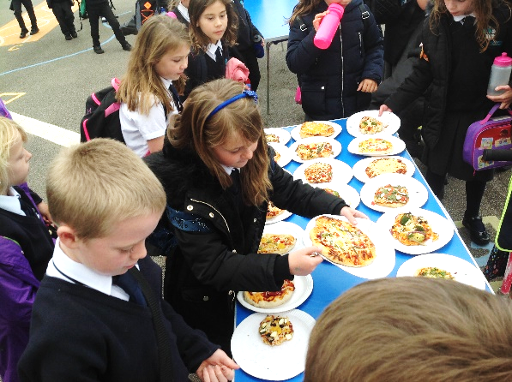
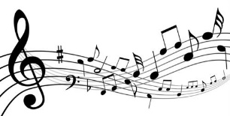
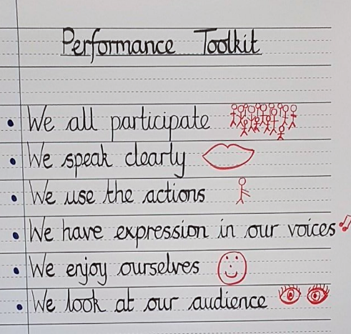
We are
musicians…
Children learned songs and the meaning behind them, discussing friendships and how we help each other out.

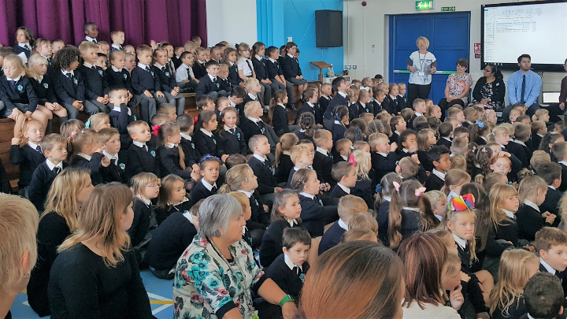

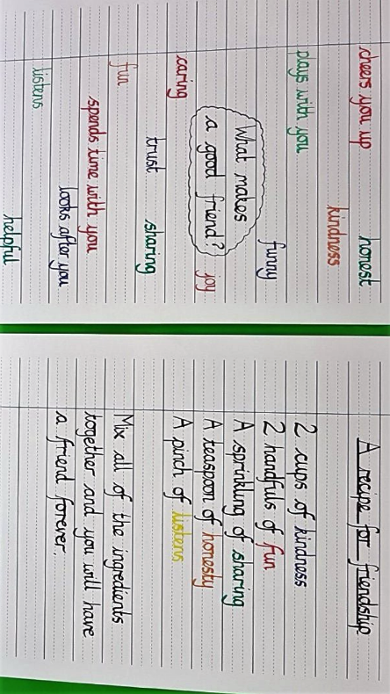
They learned about performance which they had the opportunity to display to a full packed audience and now apply their learning in other topics as well.

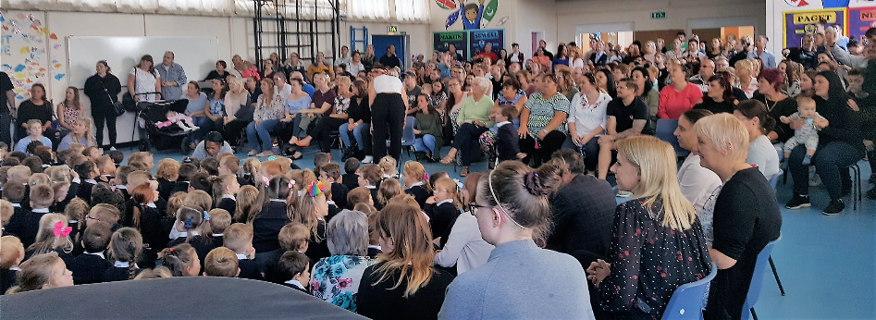
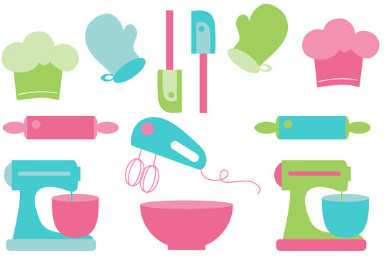

We are design
technologists…

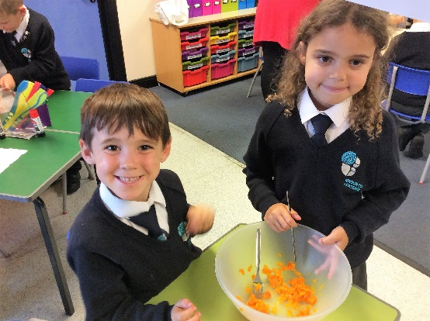
Children learned about harvest, local food produce and where food produce comes from when we can’t get it here in England.

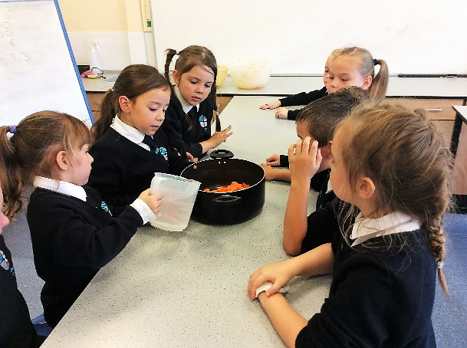

They used their knowledge to read and write recipes, producing some wonderful foods which they sold at our Food Festival Fundraiser.

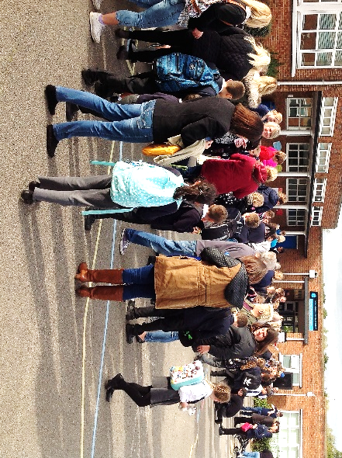

Thanks to the wonderful support of our parents, the children raised £439. The children are deciding this week just what to spend the money on for the shoeboxes that each class is filling for the Shoebox Appeal.

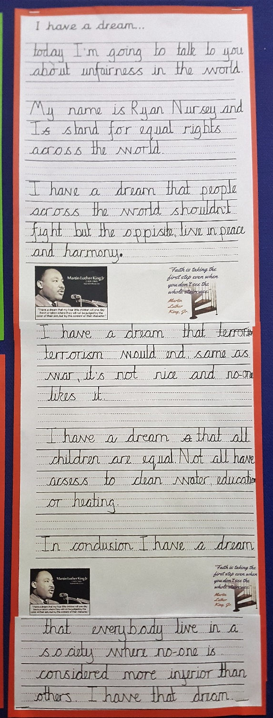
We are
historians…

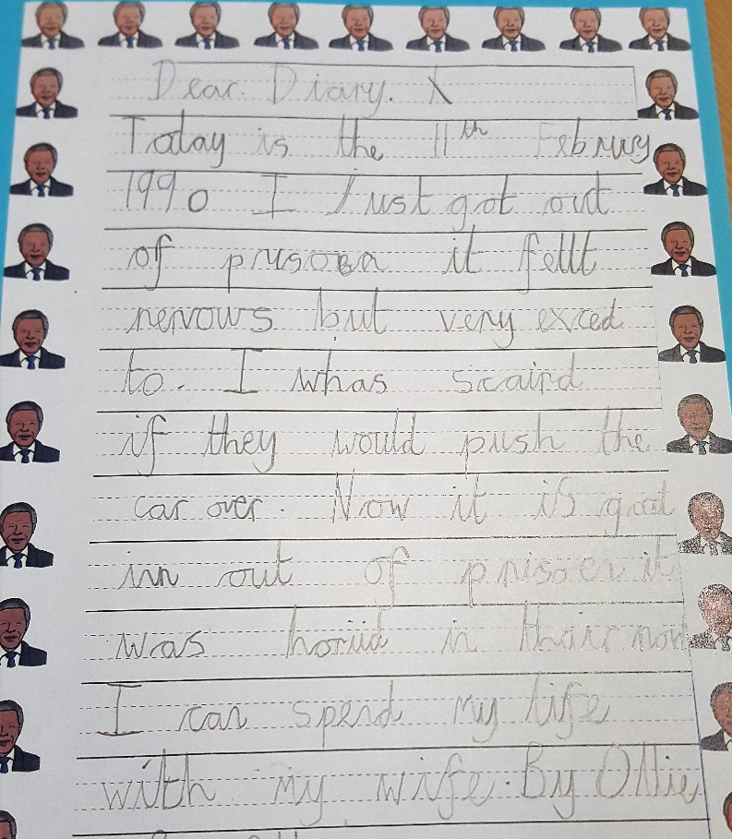

The study of inspirational black activists throughout history was truly motivational. They thoroughly understood and were outraged at the thought of unfairness and inequality. They have a beautiful dream for our world!

And what’s to come…

Autumn Term 2
30th October | Science | We are Scientists:  World Science Day science fair
6th November
13th November | Geography | We are Geographers:  ‘A trip around the world’ classroom transformations
20th November
27th November
4th December | Religious Education and Music | We are Musicians:  Christmas productions  Carol singing in the community
11th December
18th December

Spring Term
Week commencing | Knowledge on display | KoD outcome
1st January (2 days) | Art | We are Artists:  World’s great artists –  Portrait and Landscape Art Exhibition
8th January
15th January | Science | We are Scientists:  Science Fair
22nd January
29th January | History | We are Historians:  Significant events -  Story-telling assembly
5th February

19th February | Geography | We are Geographers:  Maps and globes – Quiz masters
26th February
5th March | Music/ICT | We are Musicians:  Performing through instruments and technology
12th March
19th March | Science | We are Scientists:  Science Fair
26th March

Summer Term
Week commencing | Knowledge on display | KoD outcome
16th April | Art | We are Artists:  World’s great art media –  Art Exhibition
23rd April
30th April | Science | We are Scientists:  Science Fair
7th May
14th May | History | We are Historians:  A time-line through history
21st May

4th June | Science | We are Scientists:  Science Fair for parents
11th June
18th June | PE | We are Athletes:  Sports days
25th June
2nd July | Music | We are Musicians:  Compositions through poetry
9th July | History | We are Historians:  An inspired classroom
16th July

We look forward to your continued support at upcoming events which celebrate learning – keep an eye out for newsletters and flyers for dates.

