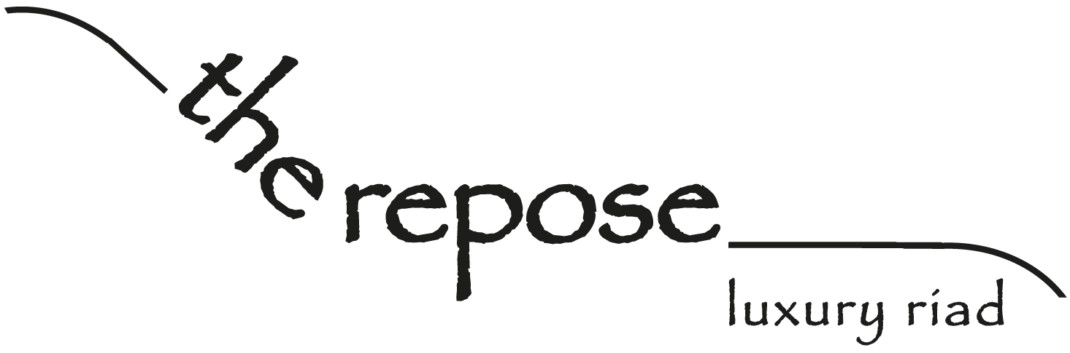

www.therepose.com therepose@gmail.com
00 212 537 88 29 58 rachid: 00 212 661 54 77 38 jan: 00 212 678 48 62 58
17 zankat talaâ , ras chejra, salé medina, morocco
From the Casablanca direction ...

Exit the motorway at Rabat. Continue straight on, straight on, straight on. You will go through various traffic lights and roundabouts. Eventually you will see Rabat Medina wall on your left, continue going straight on, keeping this on your left. You will cross the river to Salé on the new bridge. Stay in the right hand lane. Before you get to the end of the bridge, you will see the Marina signposted on your right. Turn right and, at the bottom of the hill, turn left. Go straight on (cross the tram lines), then take the first right. Go straight on, with the Medina wall on your right. You will see a Shell petrol station on your left. After about 800m, there is a small roundabout and you go straight on, through a gap in the Medina wall, keeping the medina wall on your left. After about 800m, the road widens and there are lots of parked cars. You will see 'Pharmacy Basma' on your right, stop here and we will be here waiting for you (we are 2 minutes from the car park).
Here is a link to our Google Map with 'The Repose' position marked:
http://maps.google.com/maps/ms?hl=en&ie=UTF8&msa=0&msid=107807205266907764052.00048d1c1b467391bf3c4&ll=34.039298,-6.827531&spn=0.004374,0.009645&z=17
Here are our Google Maps coordinates: 34°02'21.6"N 6°49'32.8"W
If you give us a quick phone call when you get to Salé, then we will go to the end of the road to wait for you.

