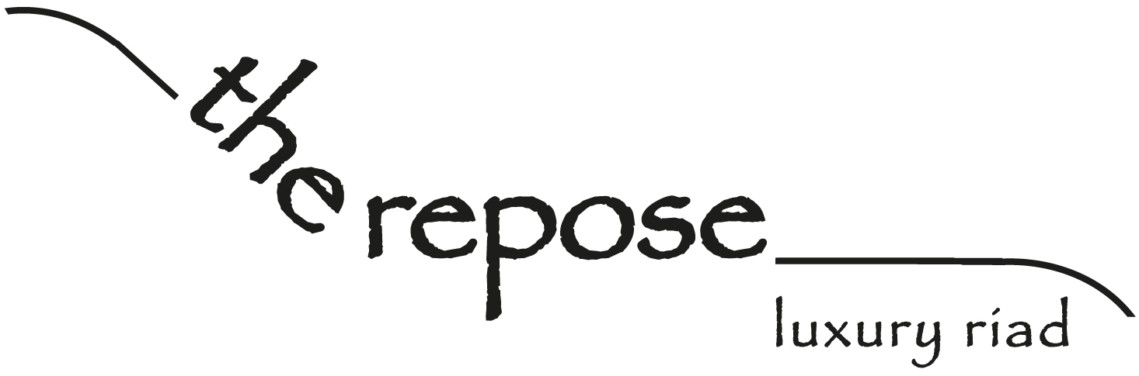

www.therepose.com therepose@gmail.com
00 212 537 88 29 58 rachid: 00 212 661 54 77 38 jan: 00 212 678 48 62 58
17 zankat talaâ , ras chejra, salé medina, morocco
From the Tangier / Fes direction ...

From the Tangier, Fes direction ... Exit the motorway signposted Rabat/Salé airport. Continue straight on, past the airport on your right. Continue straight on through various traffic lights and roundabouts. Eventually, you will go under a railway bridge. Directly after that, there is a roundabout, take the second exit and then take the first left (just before the tram lines). Go straight on (you will be parallel with the tram lines on your right now). At the traffic lights, turn right (cross the tram lines), then take the first right again. Go straight on, with the Medina wall on your right. You will see a Shell petrol station on your left. After about 800m, there is a small roundabout and you go straight on, through a gap in the Medina wall, keeping the Medina wall on your left. After about 800m, the road widens and there are lots of parked cars. You will see 'Pharmacy Basma' on your right, stop here and we will be here waiting for you (we are 2 minutes from the car park).

Here is a link to our Google Map with 'The Repose' position marked:
http://maps.google.com/maps/ms?hl=en&ie=UTF8&msa=0&msid=107807205266907764052.00048d1c1b467391bf3c4&ll=34.039298,-6.827531&spn=0.004374,0.009645&z=17
Here are our Google Maps coordinates: 34°02'21.6"N 6°49'32.8"W
If you give us a quick phone call when you get to Salé, then we will go to the end of the road to wait for you.

