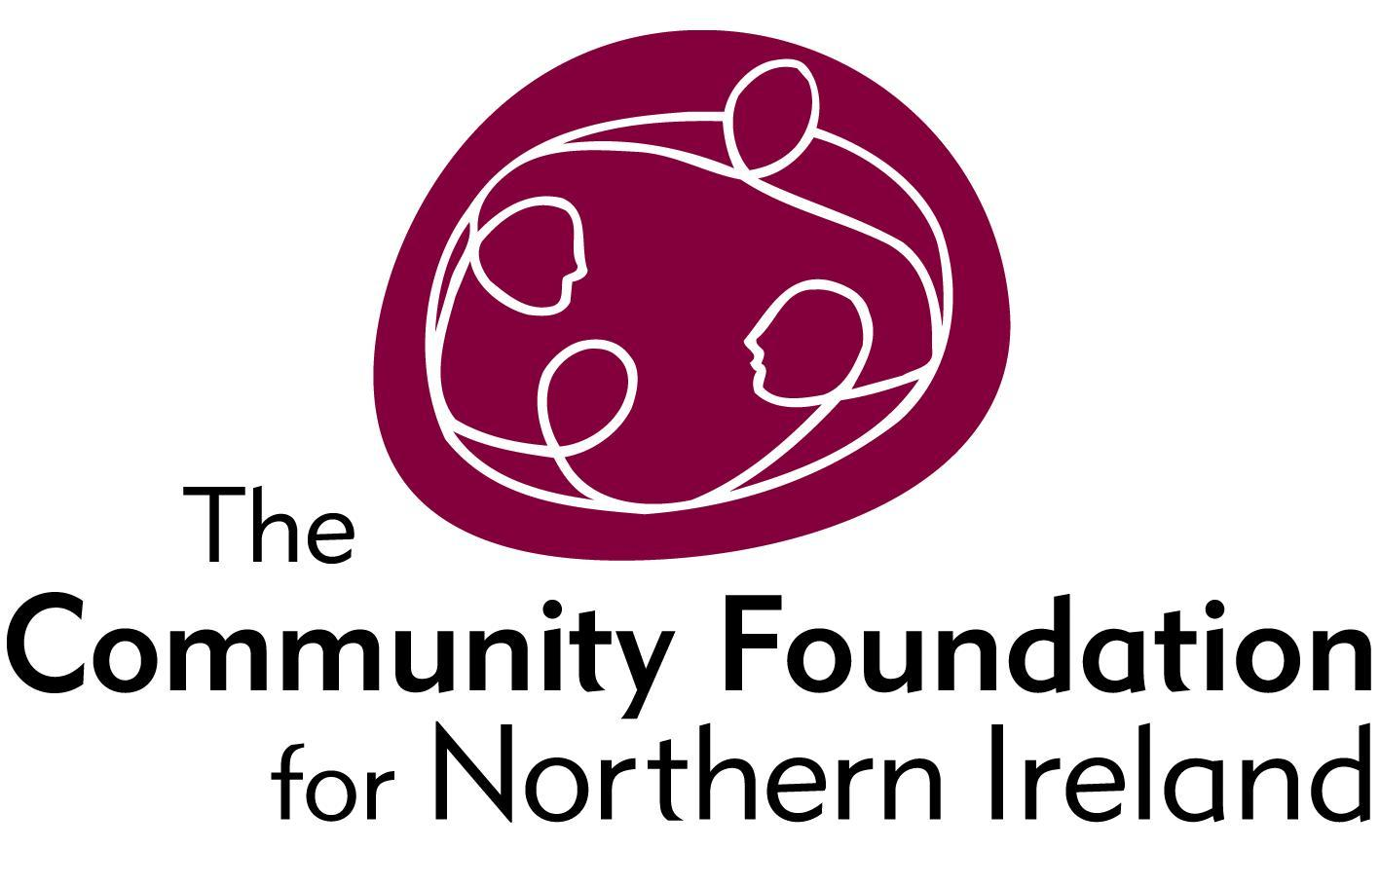
Terms of Reference for Research Project

June 2017

- BACKGROUND TO COMMUNITY FOUNDATION NI

The Community Foundation for Northern Ireland seeks to connect people who care to causes that matter.

For over 35 years the Community Foundation has been a trusted, secure means through which donors choose how, when and where they give, by helping them to set up funds, supporting them to make grants and to see the impact of their donations on local communities who are in greatest need.

We believe that a vibrant Community Foundation is a vital part of helping Northern Ireland move forward as an institution independent of the government and beyond party politics, built on voluntary contributions from the community and caring about the most marginalised and vulnerable in society.

The role of the Community Foundation is to develop a culture of giving based on relationships – as opposed to transactions – from local people and those with a local connection; to be a vehicle for connecting communities, enabling them to learn from others doing similar work, to share and be supported, and to feel the strength of people joining forces.

We bring donors and local communities together, supporting people to direct their giving to issues and causes that are important to them and to where it is really needed.

We do this because we want to see a Northern Ireland that is peaceful, equitable and values the contribution of local people and communities in achieving a shared and socially just society.

2.0 STRATEGIC AREAS

We outwork our vision in three strategic areas:

- Community Impact - making grants (and potentially other forms of social finance) to support local communities, particularly to help the most marginalised and vulnerable, and investing in the kind of projects that other funders might not fund.

- Donor Development - effectively helping donors direct their money to causes that make a difference.

- Community leadership - listening to the communities we’re working with, and based on what we’re hearing advocating on their behalf.

3.0 VALUES

While pursuing our passion for giving and for social justice, we hold each other to account to act with the following values:

- independence, particularly from government and political affiliations

- innovation in our approaches to supporting communities and working with donors

- flexibility and proportionality in how we work with communities we’re supporting

- empowerment of staff and communities

- risk taking in the projects we choose to engage with

- the importance of transparency and honesty

4.0 THE RESEARCH PROJECT

“To record and critically analyse the work of the Community Foundation with former politically motivated prisoners of non-state organisations from the time of the paramilitary ceasefires until 2014.”

  - Research Context

The Community Foundation has taken calculated risks for peace. As early as the first EU PEACE Programme, the Foundation realised the critical importance of reintegrating politically motivated former prisoners into civic society and funded projects to this effect. Criticism was quick from those who wished to exclude former prisoners and combatants from conflict resolution processes. The engagement with former prisoners continued during PEACE II and PEACE III and culminated with a partnership of organisations representing the former prisoners of the five main paramilitary organisations, Prison to Peace (P2P).

  - Aims of Research

The aims of this research proposal include: recording the work of the Foundation; constructing critical analysis; drawing conclusions that capture the lessons learned; and, develop a model of engagement relevant to community foundations and philanthropic organisations working towards conflict resolution outcomes the world over. The Foundation’s experience in peace-building is unique and the learning potential invaluable. We are deeply committed to learning; we take risks and that means we don’t always get things right. We expect any evaluation and research into the work of the Foundation to provide robust challenge where required, and this work is no different.

  - Process & Approach

The process will be rigorous and comprehensive research; the product will be a publication for targeted circulation at home and abroad and will include the Foundation’s work not just through the Peace Programmes but also the following:

- Peace Impact Programme
- Communities in Transition
- Creating Space Learning & Sharing Project
- Social Justice (Small Grants)
- A Community Development Approach to Social Justice
- SEARCH Project
- Demonstration Projects

The research should be broken down into two areas:

- Strand One - Engagement with former prisoners and combatants organisations to assess the experience of partners/beneficiaries and analyse the positive and negative impacts of the engagement;

- Strand Two - Documentation of Community Development approach to peacebuilding, risks taken for peace & impact with emphasis on the models and approach used by the Foundation over this period.

The research should include:

- A literature review of all the relevant records of the Foundation in storage or in the public domain to ascertain the context of engagement with former prisoners. This should include evaluations of the projects, PEACE programmes, and media coverage.
- Key informant structured interviews with (at least three) former Community Foundation staff who played central roles in this engagement
- Key informant structured interviews with (at least three) current Community Foundation staff who played central roles in this engagement
- Key informant structured interviews with (at least three) members of each of the five ex-prisoners and combatants organisations to assess the experience of partners/beneficiaries and analyse the positive and negative impacts of the engagement
- Key informant structured interviews with (at least five) representatives of civic society, including PSNI, to assess impact of the work within and external to the former prisoners’ communities.
- Write up of a final Report. The Report will be evidence-based, methodologically rigorous, but amenable to a general readership. It will capture and share the learning from the Foundation’s experience for CFNI and for philanthropic organisations operating in conflict-prone contexts.
- The conclusion should include learning for the Foundation and implications, if any, for future work. We are deeply committed to learning; we take risks and that means we don’t always get things right. We expect any evaluation and research into the work of the Foundation to provide robust challenge where required, and this work is no different”

The Foundation would particularly welcome the inclusion of Ulster University and/or Queens University Belfast in the research and analysis of the piece of work.

5.0 STRUCTURE OF THE FINAL REPORT

The structure of the reports must be as follows and as a minimum the report should contain:

- Abstract
- Introduction - to put final report into context and to set the scene
- Methodology
- Discussion and Analysis of Findings
- Conclusions
- Recommendations
- Appendix: Sources of Research
- Appendix: Bibliography

A ‘printer ready’ Executive Summary must also be developed.

6.0 DELIVERABLES

- Final report (proof read) as set out above in a word document
- A ‘printer ready’ Executive Summary
- Any data collected and or collated provided to the Foundation on completion of the assignment

7.0 DELIVERY TIMETABLE

The preferred tender will be required to complete the project within the timeline outlined below. Individuals/organisations seeking to carry out this contract should be available in line with the following draft schedule and be in a position to prioritise this work for the Community Foundation.

- Initial meeting with CFNI to discuss approach w/c 24th July 2017

- Review meeting with CFNI to discuss progress week commencing 21st August 2017
- The first draft of the Reports should be delivered to the Community Foundation by 29th October 2017
- This draft will be reviewed by the Community Foundation during the week commencing 2nd November 2017
- The Reports will be progressed, refined and finalised by the researcher by 24th November 2017
- The final report should be delivered to the Community Foundation by 1st December 2017

8.0 COPYRIGHT

Authorship of the works will be acknowledged. However the copyright and any other intellectual property on materials provided by the Community Foundation or produced on their behalf, shall vest with the Community Foundation. All materials received, and software files created in the course of this project, should be returned to the Community Foundation at the conclusion of the project, in an agreed format. The reports should be produced based on the above dates and a copy made available to the Community Foundation for Northern Ireland. The Community Foundation for Northern Ireland should be invoiced for the work carried out on their behalf and the agreed contract sum will be paid on receipt of a satisfactory report by the delivery date.

9.0 SELECTION CRITERIA

Tenders will be selected for their ability to demonstrate a high quality and rigorous approach that offers value for money to the Community Foundation. You should highlight your suitability to fulfil the brief using examples of contracts you have worked on over the last two years.

9.1 Pass or Fail Criteria

- Work undertaken in relation to carrying out commissioned research. Examples within the last 2 years should be drawn upon.
- Confirmation of capacity to deliver the work over the specified timeframe.

9.2 Weighted Scoring Areas:

Criteria | Score
Understanding of the operating context and ethos of the Community Foundation for Northern Ireland | 10%
Methodology | 30%
Understanding of the brief | 40%
Value for money | 20%

The person(s) or organisation appointed will report to the Community Foundation’s Impact Director in the first instance.

10.0 MAKING A RESPONSE

You should respond to the invitation by supplying a proposal, via one electronic copy, sent to dshackels@communityfoundationni.org that should inter alia include the following components:

- Your understanding of the brief including the methodology and proposed approach
- Any comments you wish to make on the proposed approach
- Your ability to fulfil all the tasks and deliver the outputs in the timeframe outlined
- Who will be involved in the research with respective CVs
- That you will be contracted on a self-employed basis
- A statement of experience detailing your work in this area of research
- The names and addresses of two clients for whom you have completed similar assignments (detailing the nature of the work undertaken for them).

Please note that while we have not attached a specific cost to this evaluation process, we anticipate it to be in the region of £13k to £15.k exclusive of VAT and we anticipate that this should take between 50-60 days work. It is imperative that the successful applicant provides a flexible and robust approach alongside excellent value for money. Note that this is a maximum price contract, individuals/organisations should price accordingly to gain a competitive advantage.

11.0 FURTHER INFORMATION

Contact: Dawn Shackels, Impact Director
Email: dshackels@communityfoundationni.org

Queries will only be accepted by email and responses will be published on the Community Foundation’s website. Queries will not be accepted after Wednesday 5th July 2017.

12.0 CLOSING DATE

The closing date for receipt of tenders is 12 noon Monday 17th July 2017. Tenders should be emailed to dshackels@communityfoundationni.org. Tenders received after the closing date will not be considered.

Note that the Community Foundation is not obliged to appoint the lowest or any tender.

The standard UNO mechanism for peace processes is DDR viz. demilitarisation, demobilisation and reintegration.
INLA, OIRA, PIRA, UDA, South East Antrim UDA and UVF (in alphabetical order).

