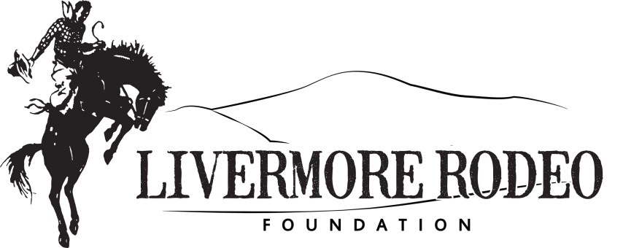

*The Mission of the Livermore Rodeo Foundation is to make a difference in the lives of individuals, families,*

*and organizations through community donation and volunteer commitment.*

January 2016

The Livermore Rodeo Foundation (LRF) was founded in 2008 as a non-profit organization in a partnership with The Livermore Stockmen’s Rodeo Association (LSRA). They both have the goal of giving back to the community and keeping the spirit, heritage, and tradition of agriculture, ranching and rodeo alive. This year the Livermore Rodeo will celebrate its 97th year of rodeo tradition. In the midst of World War I, the Rodeo was initially formed to raise money to support the efforts of the Red Cross in helping soldiers and veterans. As the foundation was created it was easy to follow the same desire, and continue to remind people of how it all really began. The determination and hard work of LSRA and LRF has created a unique partnership that is committed to encouraging and helping keep the sport of rodeo here in the Livermore community.

Livermore Rodeo Foundation hosts annually a Queen Dinner Fundraiser, the Miss Livermore Rodeo Princess Program and the Buckin’A Saloon-Rodeo After Party with remarkable success. This year we are proud to announce the Cowgirl Luncheon is under our Rodeo Foundation. Along with other fundraising efforts and donations, Livermore Rodeo Foundation to date has given $72k to organizations within the Livermore Community.

LRF has supported Livermore Future Farmers of America, local 4-H clubs, Alameda County Fair Livestock Boosters, Livermore Jr Rodeo, Livermore High School Agriculture Program, LARPD, Student Scholarships, Wounded Warrior Project, Livermore Valley VFW and Valley Care Health Library & Ryan Comer Cancer Resource Center.

We are very proud of our efforts and the opportunity our events provide for us to financially support local organizations. Your support would be greatly appreciated. Livermore Rodeo Foundation values our community and always appreciates support from Business Leaders.

Enclosed is our Sponsor Form. We have several levels of support available and donations can be allocated directly to specific programs of your interest.

If you have any questions, feel free to contact Kathleen Minser at 925 858-6225 or [kminser@hotmail.com](mailto:kminser@hotmail.com).

Thank you in advance for your consideration!

Livermore Rodeo Foundation

PO Box 646

Livermore CA 94551

www.livermorerodeo.org

**­­­Rodeo Foundation**

**Board of Directors**

**Board Officers**

*Kathleen Minser - President*

*Ask Kathleen*

*Retired Waste Management*

*Mark Kaufman – Vice President*

*Oakland - Alameda County Coliseum Authority*

*Walt Lupeika - Treasurer*

*Certified Public Accountant*

*Kathryn Laughlin - Secretary*

*Rock Creek Ranch*

**Board of Directors**

*Diana Luna*

*LLNL*

*Don Podesta*

*Retired LLNL*

*Don Staysa*

Retired Alameda County Fire Fighter

*Heather O’Connell*

*Wells Fargo*

*Jim McGrail*

*Winery Owner*

*Lawyer*

*Zone 7 BOD*

*Sara Eads*

*Chicago Title*

*Tiffany Brown Waller*

*Union Bank*

*Viki Groffman*

*Peixoto Performance Horses*

**Board Liaison Directors**

*Donnie Perry*

*LSRA President*

*LLNL*

*John Goltz*

*LLNL*

**Board Associate Members**

*Chris Waller*

*Field Service Engineer*

*Tim O’Connell*

**Advisory Board**

*Kirsten Barranti*

*Barranti Law Group*

*Livermore Rodeo Foundation is a 501c3 non-profit. Tax Exempt ID #80-0272028 Donor Received no goods or services and your donation is tax deductible to the full extent of the law.*