Role play - Customer Service– Difficult Customer

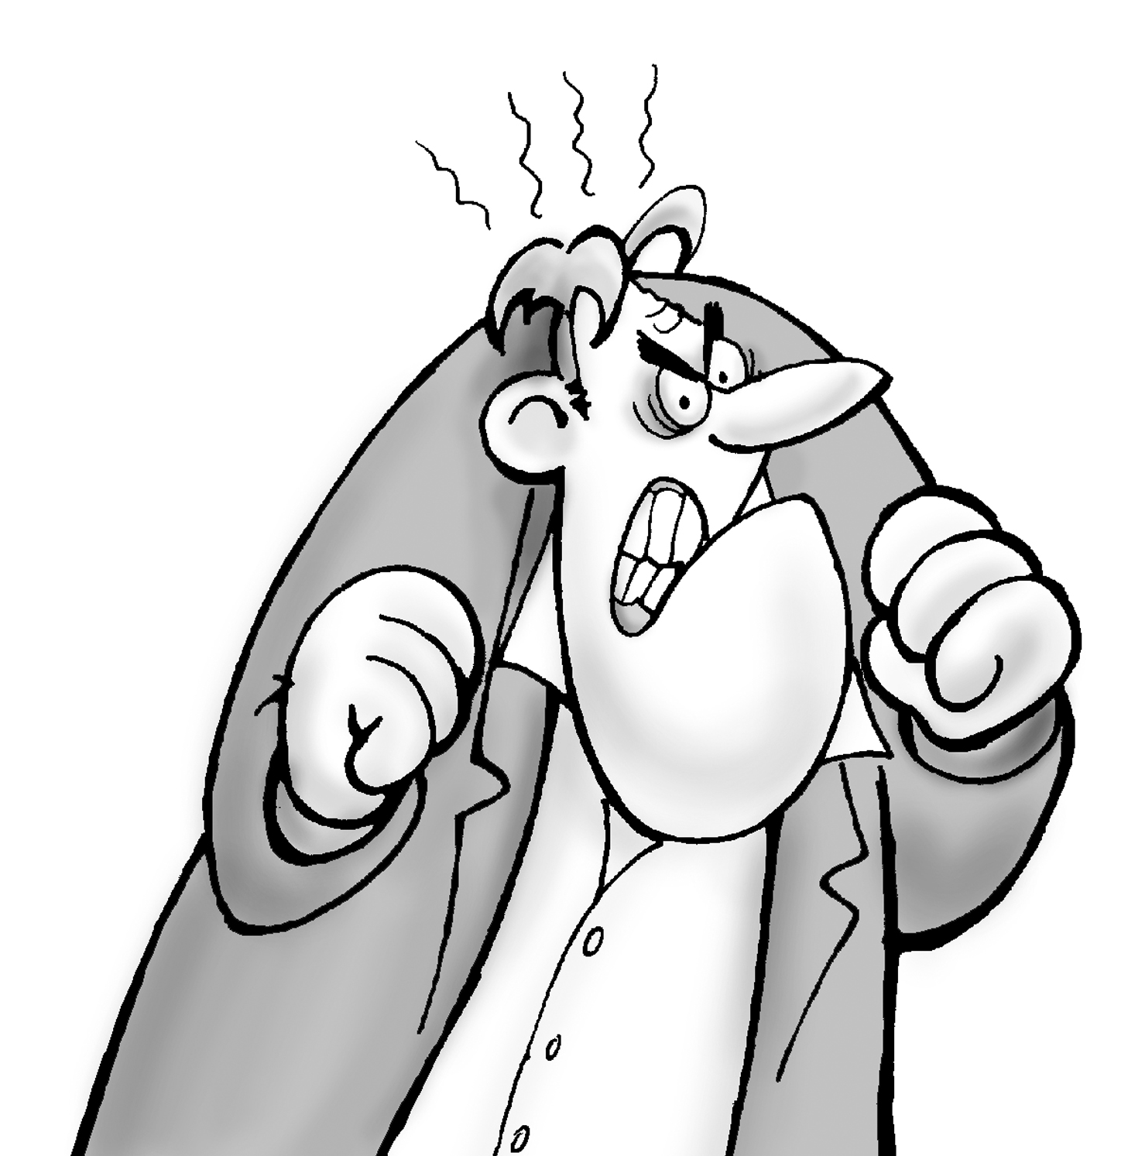

Role A

You need to have some spare parts immediately as your machine has broken down. You know what parts you need so you decide to go the shop and buy them. You actually see the parts you need on the top shelf of the store, but when you ask the assistant they tell you they are not for sale.

When you ask why they say they have to keep them in stock for their technicians. So you ask if they have others in the stock room in which they can sell to you. They say they that they sold the last of them that morning.

You ask the sales assistant if you can buy those on the top shelf evening offering more money.

The assistant tells you that he is not authorized to to sell them. You are beginning to lose your temper. You need the spare parts today as you have an important order to fill and if you do not do it today you will lose the account.

You demand to speak to the manager. The assistant tells you that the manager is busy. You are now very angry and refuse to leave the shop until you have your spare parts!!!

Role B

You are the stock assistant for a supplier of spare parts. You have had a bad day you boss has been giving you a hard time all day. His last orders to you were to under no circumstance is to be interrupted by anyone, no matter what the problem is, and more especially by you-

A client arrives and wants the spare parts reserved for the technicians. You have told your boss many times to keep these stored elsewhere but he has never listened to you.

You have told the client that there are none of the spare parts that he wants left having sold the last of them this morning.

The client has now asked to have those reserved for the technician even offering more money. You have to tell him that you are not authorized to do that .

When he asks to speak to the manager you have to tell him that he is busy.

The client is now very angry and is refusing to leave until he has even spoken to the Manager or he has the spare parts.

Decide what you should do and what action you should take.

Useful phrases
Customer

I need to have …..

I demand to have ….

I am not happy about this at all ….

I demand to speak to the manager….

Let me speak to someone with more authority….

This is not good enough…

I want to speak to the person in charge .. now!

Store assistant

I am sorry ....

I understand but....

Please understand ...-

I am sorry sir/madam .. But the manager is busy at the moment...

Perhaps i could order them for you ....

I am not authorized to do that .....

I can recommend another supplier ....

Please sir/madam ... If you calm down a minute ....

Let me see if there is something else i can do ........

Lets see if there is an alternative solution .....

You could always come back Tomorrow sir/madam ….



